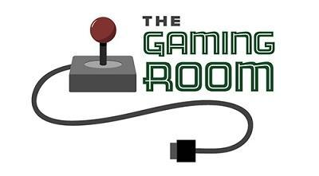

Draw It or Lose It

CS 230 Project Software Design Template
Version 3.0

Table of Contents

CS 230 Project Software Design Template 1
Table of Contents 2
Document Revision History 2
Executive Summary 3
Requirements 3
Design Constraints 3
System Architecture View 3
Domain Model 3
Evaluation 4
Recommendations 5

Document Revision History

Version | Date | Author | Comments
1.0 | 11/16/2025 | Samuel Parnell | Implemented the Entity base class and refactored Game, Team, and Player to inherit from it. Updated GameService to enforce the singleton pattern, ensure unique IDs for games, teams, and players, and check for duplicate names using iterators. Added methods to add/remove teams and players while maintaining uniqueness. Updated ProgramDriver and SingletonTester to demonstrate functionality and singleton behavior.
2.0 | 11/30/2025 | Samuel Parnell | Expanded the Software Design Document to include a full evaluation of operating platforms (Linux, Windows, macOS, and mobile) for both server-side hosting and client delivery. Added analysis of development requirements, toolchains, and cross-platform considerations. Completed the Evaluation table and added detailed recommendations covering architecture, storage management, distributed systems, and security considerations.
3.0 | 12/14/2025 | Samuel Parnell | Expanded the document to include full evaluation and recommendations for operating platforms and development tools; updated the Domain Model and architecture analysis for clarity; incorporated memory, storage, and distributed systems considerations; refined maintainability and extensibility recommendations.

Instructions
Fill in all bracketed information on page one (the cover page), in the Document Revision History table, and below each header. Under each header, remove the bracketed prompt and write your own paragraph response covering the indicated information.

Executive Summary

Draw It or Lose It is a web-based multiplayer party game inspired by classic “Win, Lose or Draw” mechanics. The system presents teams with a sequence of stock drawings that progressively reveal a target phrase/title/thing. Gameplay consists of four 60-second rounds where drawings render progressively and are fully visible at 30 seconds. If the active team doesn’t guess within the round time, other teams have a single 15-second opportunity to supply a final guess.

Requirements

Support Multiple Teams:
- The system must allow a game session to include one or more teams participating simultaneously.

Support Multiple Players per Team:
- Each team must be able to contain multiple players, reflecting real-world gameplay structure.

Unique Naming:
- Game names must be unique so users can verify that a desired game session name is available.
- Team names must be unique within a game to avoid confusion during gameplay.

Game Flow Support:
- The system must support the game’s structure of four rounds, timed at one minute each, with drawings progressively revealed and additional guessing opportunities for other teams if the active team fails.

Scalable Web-Based Delivery:
- The application must eventually support web-based access for multiple simultaneous users.

Single Instance of Game Management:
- Only one instance of the game management service may exist in memory at any time to avoid conflicting game states. This will be implemented using the Singleton design pattern.
Unique Identifiers for Domain Objects:
- The system must generate unique IDs for every instance of a Game, Team, or Player. These IDs are to be managed centrally within the game management service.

Name Uniqueness Enforcement:
- The system must enforce uniqueness of game and team names by searching existing collections using the iterator design pattern.

Object-Oriented Domain Model:
- The application must use a shared base class (Entity) to provide common attributes (id, name) for all major objects (Game, Team, Player).
Extensibility:
- The system should be structured in a way that allows future expansion, including UI layers, networking, database persistence, and additional game features.
Platform Flexibility:
- The design must support future deployment to multiple platforms including desktop, mobile, and browser environments.

Maintainability & Readability:
- Code must follow industry best practices, proper naming conventions, documentation, and clear separation of responsibilities between classes.

Design Constraints

Web-Based Distributed Environment
- Stateless HTTP front ends will interact with the backend. All persistent states should be stored centrally in a service or database. For the prototype, in-memory collections will be used; future work will adapt persistence to a DB (e.g., PostgreSQL, MongoDB).
- Implication: In-memory singletons are valid for prototyping and local runs but must be adapted (or replaced by a distributed state manager) for multi-instance deployments.
Single Instance Game Service (Singleton)
- Only one GameService should manage games in memory during a single application runtime. This simplifies coordination and prevents accidental creation of conflicting game registries.
- Implication: In multi-server deployments, the singleton becomes per-process and must be replaced by a centralized state (e.g., Redis) or coordinated via APIs.
Unique Names & IDs
- Game and team names must be unique. Use in-memory name checks (iterator) and a unique numeric ID generator for Game, Team, and Player.
- Implication: Must consider case-sensitivity rules (recommendation: case-insensitive uniqueness for friendly UX).
Timing & Rendering
- Game rounds are time-bound (60s rounds, drawings complete at 30s, 15s guess window for other teams). The UI will need a deterministic timer mechanism and the backend must produce drawing-tick events or timestamps for rendering.
- Implication: Backend should provide authoritative timestamps or tick events for playback consistency across clients.
Concurrency
- Multiple users may try to create teams or games with the same name simultaneously.
- Implication: The production system must protect uniqueness via atomic DB constraints or synchronization mechanisms. For a prototype, synchronized methods will simulate this.
Extensibility
- System must allow future features: persistence, authentication, match-making, spectators.
- Implication: Design domain objects and services with clear boundaries and interface points.

System Architecture View

Please note: There is nothing required here for these projects, but this section serves as a reminder that describing the system and subsystem architecture present in the application, including physical components or tiers, may be required for other projects. A logical topology of the communication and storage aspects is also necessary to understand the overall architecture and should be provided.

Domain Model

Key classes (per UML):
- Entity (base class): Contains id (long) and name (String). Common behavior: getters/setters, toString(). All domain objects inherit this.
- Game extends Entity: Represents a game session. Attributes: list of Teams, current round, start time, unique gameId (inherited as id). Behavior: add/remove teams, startRound, endRound, check uniqueness of team names within game.
- Team extends Entity: Attributes: list of Players, score. Behavior: add/remove players.
- Player extends Entity: Attributes: possibly player-specific attributes like isActive, connectionId.
- GameService (Singleton): Manages all Game instances in-memory. Holds counters for nextGameId, nextTeamId, nextPlayerId (static fields). Methods: addGame(), getGameByName(), addTeam(), addPlayer(), name-uniqueness checks.
Object-oriented principles demonstrated:
- Encapsulation: Each class exposes behavior through methods and hides internal lists/ids.
- Inheritance: Game, Team, Player inherit common attributes/behaviors from Entity, reducing duplication.
- Single Responsibility: GameService manages registration and global lifecycle; domain objects manage their internal state.
- Polymorphism: Code working with Entity references can treat games/teams/players uniformly when needed.
- Iterator Pattern: Used to traverse lists to find by name and ensure uniqueness.
- Singleton Pattern: Applied to GameService so a single service instance manages the runtime state.

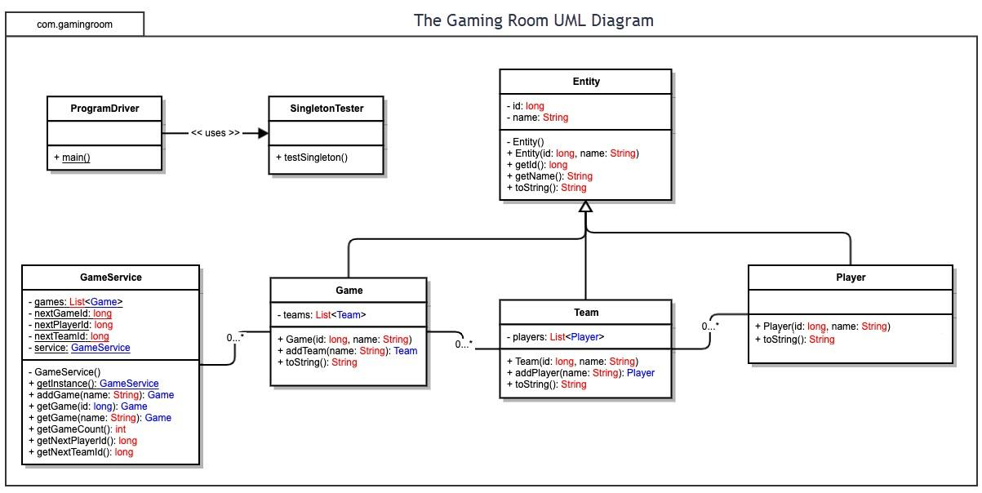

Evaluation

Using your experience to evaluate the characteristics, advantages, and weaknesses of each operating platform (Linux, Mac, and Windows) as well as mobile devices, consider the requirements outlined below and articulate your findings for each. As you complete the table, keep in mind your client’s requirements and look at the situation holistically, as it all has to work together.

In each cell, remove the bracketed prompt and write your own paragraph response covering the indicated information.

Development Requirements | Mac | Linux | Windows | Mobile Devices
Server Side | macOS can host web applications (Apache, Nginx, Node.js), and its Unix-based foundation makes it reliable for development and small-scale hosting. However, macOS is rarely used for large production deployments due to higher licensing and hardware costs and fewer server-grade options. Use macOS primarily for development and testing, not large-scale hosting. | Linux is the industry standard for web hosting and scales well to thousands of users. It is stable, secure, and cost-effective (many distributions are free). Linux offers broad tooling for web servers, containers, orchestration (Docker/Kubernetes), and cloud deployment, making it the best choice for production hosting. | Windows Server supports IIS and integrates tightly with Microsoft stacks (.NET, Active Directory). It is suitable when relying on Microsoft technologies but usually involves licensing costs and higher overhead. For open-source Java/Node/Python stacks, Linux is typically more efficient and cost-effective. | Mobile devices are clients, not servers. They lack the uptime, networking stability, and compute/storage necessary to host production web services. Mobile devices will only act as clients connecting to a central server.
Client Side | Deliver the app as a responsive HTML5 web interface—Mac users will access it through Safari or Chrome. Ensuring cross-browser compatibility and responsive design is the main task; native macOS apps require Swift/Objective-C expertise and are not required if a browser interface is used. | Linux desktop users will generally run the web UI in Firefox or Chrome. The main development concerns are testing across distributions and browsers. Native Linux desktop apps are rarely needed; browser-based deployment minimizes extra development effort. | Windows desktop access is covered by the same responsive web UI and tested in Edge/Chrome/Firefox. Browser compatibility testing is essential; native Windows apps require .NET/C# skillsets if pursued, which increases development resources. | Mobile requires responsive UI design and thorough testing on iOS and Android browsers. If native apps are desired, plan for separate Android (Kotlin/Java) and iOS (Swift) development or use a cross-platform framework (React Native/Flutter) to reduce duplicated work and cost.
Development Tools | macOS development tools: Xcode (native mac apps), IntelliJ/Eclipse/VS Code for Java/JS, and Docker for containers. macOS is required to build iOS apps and convenient for cross-platform web development. Some commercial tooling (Xcode is free, others may be licensed) may incur costs. | Linux supports Java, Node.js, Python, Docker, Kubernetes, and tools such as IntelliJ, Eclipse, and VS Code. It is ideal for backend/server development and cloud deployment. Most tools are open source or free, minimizing licensing costs. | Windows supports Visual Studio (commercial for some editions), .NET, Java tooling (IntelliJ/Eclipse), and WSL to run Linux tools. Licensing costs may apply for enterprise IDEs or Windows Server. Windows is best if your team targets Microsoft technologies. | Mobile development requires Android Studio (Android) and Xcode (iOS). Cross-platform frameworks (React Native, Flutter) reduce duplication. Testing requires device emulators and physical devices; additional CI tooling may be needed for app store deployment.

Recommendations

Analyze the characteristics of and techniques specific to various systems architectures and make a recommendation to The Gaming Room. Specifically, address the following:

- Operating Platform: For the server-side platform, a Linux-based environment (Ubuntu Server LTS) is the most appropriate choice for The Gaming Room. Linux offers excellent stability, security-hardening features, and strong support for containerized deployments such as Docker and Kubernetes. These characteristics make it ideal for hosting scalable web applications like Draw It or Lose It. Because the client intends to distribute the game across multiple operating systems, using a platform-agnostic backend prevents vendor lock-in and reduces long-term maintenance complexity.

- Operating Systems Architectures: The Linux server platform relies on a monolithic kernel architecture, in which device drivers, file system management, networking, and memory management all operate within kernel space. This structure provides efficient performance, low-latency request handling, and strong I/O throughput. These are crucial benefits for an image-heavy, event-driven multiplayer game. Modern Linux architectures also support modularity, allowing components to be dynamically loaded or removed as needed. For The Gaming Room, this ensures that the system can scale and adapt as new features, images, or user demands emerge.

- Storage Management: Given the game’s 1.6 GB image library, the most appropriate storage system is a cloud-hosted object storage solution, such as AWS S3, Azure Blob Storage, or Google Cloud Storage. These systems offer high availability, redundancy, built-in automatic replication, and extremely fast content delivery when paired with a Content Delivery Network. Unlike local file systems, object storage scales automatically and avoids the performance bottlenecks of hierarchical file structures when retrieving large numbers of images. Metadata tagging further improves retrieval time, which is essential for a fast-paced image-based game.

- Memory Management: The Linux operating platform uses a combination of virtual memory, paging, demand loading, and file system caching to ensure process stability and responsiveness. For Draw It or Lose It specifically, memory usage should be optimized by using lazy loading so only the current image is loaded into RAM, leveraging OS-level page caching so frequently accessed assets load faster, using GPU-accelerated rendering to offload graphical work from the CPU, and preventing memory exhaustion by avoiding bulk loading of the full asset library
Together, these techniques help the system meet the client’s requirement for rapidly rendering high-resolution images without overwhelming device memory and ensure stable performance even on limited-resource devices such as mobile phones or tablets.

- Distributed Systems and Networks: To enable communication between platforms (including mobile apps, browsers, and potential native clients) the system should be deployed as a distributed web application using REST APIs or WebSockets. Distributed software allows all clients to interact with the centralized game logic and asset store regardless of the operating system in use. Load balancers and redundant application servers will minimize the impact of outages or traffic spikes. A cloud-based Content Delivery Network ensures rapid global delivery of image assets, while horizontal scaling ensures that the system can serve more concurrent players without degradation in performance.

- Security: Security must be implemented at both the application and network layers. Best practices include enforcing TLS encryption for all data transmitted between clients and servers, storing user information using hashed and salted authentication data, limiting attack surfaces through the Linux platform’s built-in permissions model, using token-based authentication to control session access, implementing role-based access control for internal administrative tools, and employing cloud provider features such as firewalls, DDoS protection, and IAM policies. With these layers in place, user data remains protected across all platforms, even in a distributed environment.

